- SURICATA INSTALLATION VERIFICATION

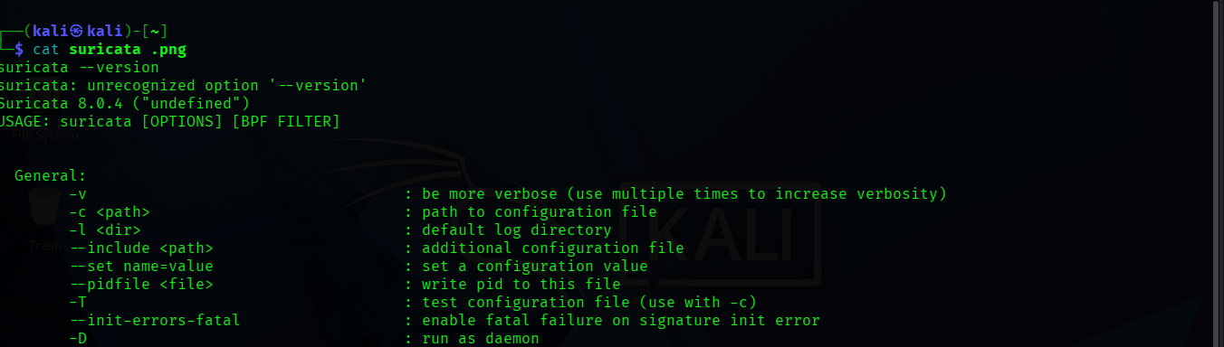

- SURICATA SERVICE RUNNING

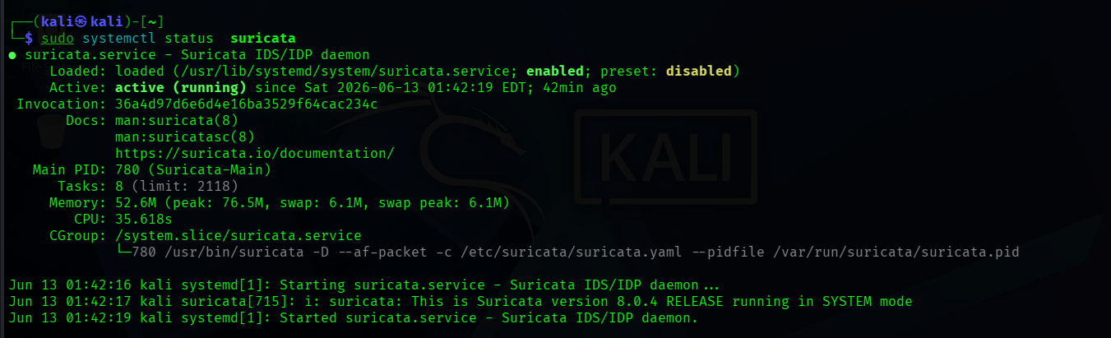

- NETWORK CONFIGURATION

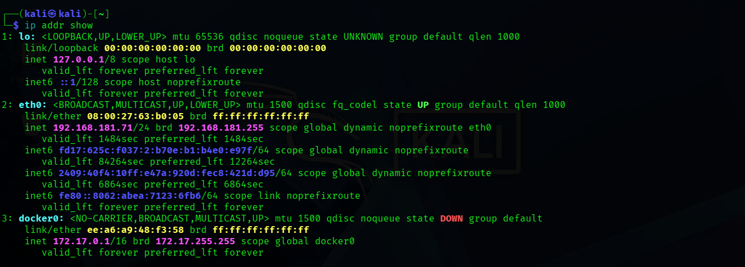

- CUSTOM DETECTION RULES

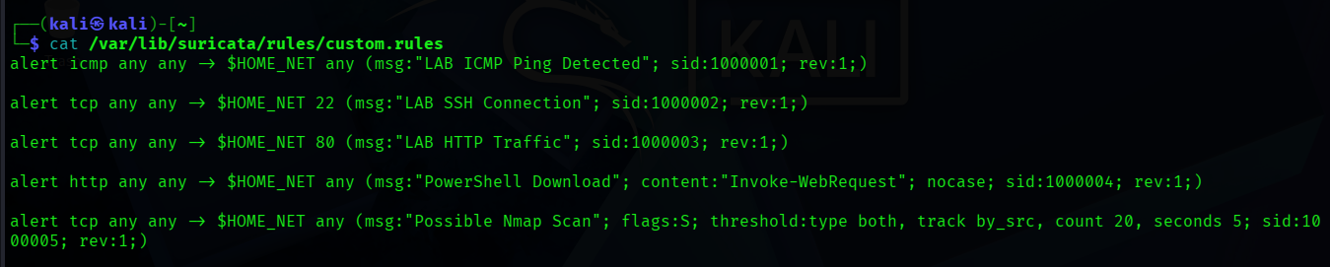

- RULE VAIDATION

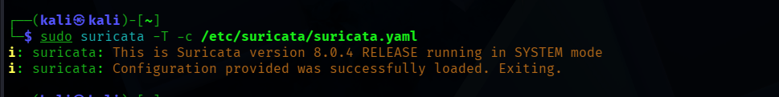

- ICMP DETECTION LAB

